**THE SPECTRUM EXAMINATIONS HUB**

**PRE-MOCK EXAMINATIONS, 2024 SET 1**

SOCIAL STUDIES WITH RELIGIOUS EDUCATION

***Time allowed: 2 hours 15 minutes***

|  |  |  |  |  |  |  |  |  |  |
| --- | --- | --- | --- | --- | --- | --- | --- | --- | --- |
| **Index No.** | **EMIS No.** | | | | | | **Personal No.** | | |
|  |  |  |  |  |  |  |  |  |

**Pupil’s Name: ……………………………………..……………………………………**

**Pupil’s Signature: ……………………………………………...........................….**

**School Name: …………………………………………………………………………...**

**District Name: ………………………………………………………………………..…**

|  |  |  |  |
| --- | --- | --- | --- |
| 1. This paper has two sections:  **A** and **B**. Section **A** has **40**  questions and section **B** has **15**  questions. The paper has **16**  printed pages.  2. Answer **all** questions. **All** working  for both sections **A** and **B** must  be shown in the spaces provided.  3. **All** answers **must** be written using  a **blue** or **black** ball point pen  or ink. Any work written in pencil  will **not** be marked.  4. Unnecessary **changes** in your work  and handwriting that cannot be  read easily may lead to **loss**  **of marks**.  5. Do not fill anything in the table  indicated: **“For Examiners’**  **use only”** and boxes | **FOR EXAMINER’S USE** | | |
| **QN. NO.** | **MARKS** | **EXR’S NO.** |
| **1 - 10** |  |  |
| **11 - 20** |  |  |
| **21 - 30** |  |  |
| **31 - 40** |  |  |
| **41 - 43** |  |  |
| **44 - 46** |  |  |
| **47 - 49** |  |  |
| **50 - 52** |  |  |
| **53 - 55** |  |  |
| **TOTAL** |  |  |
|  |  |  |

**TURN OVER**

**SECTION A (40 MARKS)**

1. Mr. Kasekende lives with his wife, their two children and a maid. What type of family do they belong to?

……………………………………………………………………………………………

2. Give any **one** reason why the coastal region of East Africa is hot yet it is near a water body (Indian Ocean)

……………………………………………………………………………………………

3. State any **one** way farmers in Africa benefit from the westerly winds.

……………………………………………………………………………………………

4. Draw a map symbol for a rift valley in the space provided below.

5. The current constitution of Uganda is the 1995 constitution. Mention any one constitution that was used in Uganda before 1995.

……………………………………………………………………………………………

6. Name the common market to which Rwanda and Burundi belonged before they joined the East African Community.

……………………………………………………………………………………………

7. State the most effective method of controlling soil erosion in highland areas like Kabale.

……………………………………………………………………………………………

8. How did the Nandi prove to be a challenge during the construction of the Uganda railway?

……………………………………………………………………………………………

9. Name the island country of Africa which is crossed by the major line of latitude marked 00.

……………………………………………………………………………………………

10. Give any **one** reason why school going children need the trade item below.



……………………………………………………………………………………………

11. In which way do televisions promote trade in East Africa?

……………………………………………………………………………………………

12. The equator crosses the Greenwich meridian at a certain point in the Atlantic Ocean. Name the point where the two lines meet.

……………………………………………………………………………………………

13. What title is given to the commander-in- chief of the armed forces

in Uganda?

……………………………………………………………………………………………

Study the diagram below and answer numbers **14** and **15.**

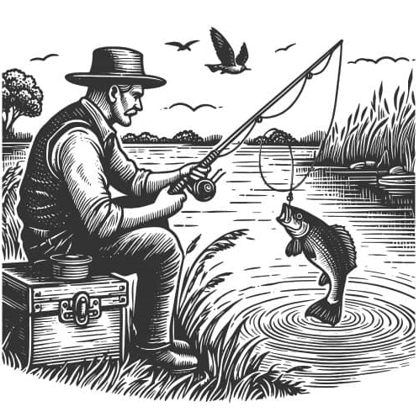

14. Name the economic activity being carried out in the diagram above.

……………………………………………………………………………………………

15. Mention anyone bad method of doing the above economic activity**.**

……………………………………………………………………………………………

16. What name is given the building in Kampala where art facts and materials of long ago are kept for public viewing?

……………………………………………………………………………………………

17. How do farmers in Uganda benefit from the Osukuru hills of Tororo?

……………………………………………………………………………………………

18. State the reason why the North Eastern region of Uganda receives cyclonic rainfall.

……………………………………………………………………………………………

19. Name the arm of government in Uganda to which security organs like the army, police and prisons belong.

……………………………………………………………………………………………

20. Give any **one** reason why some citizens of Uganda do not want to pay taxes.

……………………………………………………………………………………………

21. Name the government body in Uganda responsible for protecting animals like the ones below.

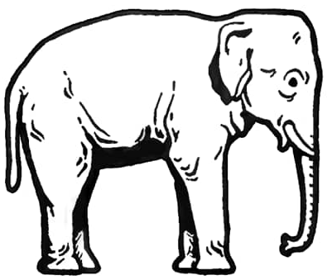……………………………………………………………………

22. Why did the population of the above animals reduce in East Africa during the Long Distance Trade?

……………………………………………………………………………………………

23. Give any one way in which the school notice board is important to learners.

……………………………………………………………………………………………

24. Mention any one administrative strategy of the Bachwezi that the

government of Uganda is using today.

……………………………………………………………………………………………

25. How were mission stations important to the missionaries during the spread of Christianity in East Africa?

……………………………………………………………………………………………

26. State the reason why most rivers in East Africa drain into the Indian Ocean.

…………………………………………………………………………………………….

27. Why would you advise a parent whose children are studying from town to send them to the village during holidays?

……………………………………………………………………………………………

28. Name the newest partner state of the East African Community.

……………………………………………………………………………………………

29. What was the name of port Kisumu by the time the Uganda railway reached Lake Victoria?

……………………………………………………………………………………………

30. Contours are lines drawn on a map joining places of the same altitude. What are isohels?

……………………………………………………………………………………………

31. Identify any one way modern means of communication have led to moral decay among the youth.

……………………………………………………………………………………………

32. Why is it wrong for school children to undermine their cooks?

……………………………………………………………………………………………

33. The claim that the first ***Mugisu*** came from mountain ***Masaba*** may be true or false. What name is given to stories of that kind?

……………………………………………………………………………………………

34. Give any one way in which coral reefs are important to the construction industry.

……………………………………………………………………………………………

35. Suggest any one reason why some eligible voters may not have interest in participating in elections.

……………………………………………………………………………………………

**For numbers 36-40, answer Either Christianity or Islam but not both alternatives in a number.**

36. **Either:** Suggest any one way in which Gospel writers got

the information they wrote in the Bible.

……………………………………………………………………………………………

**Or:** Name the book which was revealed to Prophet Isa in Islam.

……………………………………………………………………………………………

37. **Either:** Give any **one** factor which may cause a Christian not to pray

before going to sleep at night.

……………………………………………………………………………………………

**Or:** Give any **one** reason why Moslems pray before going to sleep

at night.

……………………………………………………………………………………………

38. **Either:** What lesson does a Christian learn from the story of Joseph and his brothers in Egypt?

……………………………………………………………………………………………

**Or:** What lesson does a Moslem learn from the story of Prophet Yusuf and his brothers in Egypt?

……………………………………………………………………………………………

39. **Either:**  In how many days did God create the universe?

……………………………………………………………………………………………

**Or:** How many days did Allah take to complete the work of creation?

……………………………………………………………………………………………

40. **Either:** How important is the Holy Spirit in the Church today?

……………………………………………………………………………………………

**Or:** What is the role of Angel Malik in Islam.

……………………………………………………………………………………………

**SECTION B (60Marks)**

**41. Study the map of East Africa below and answer questions about it**.

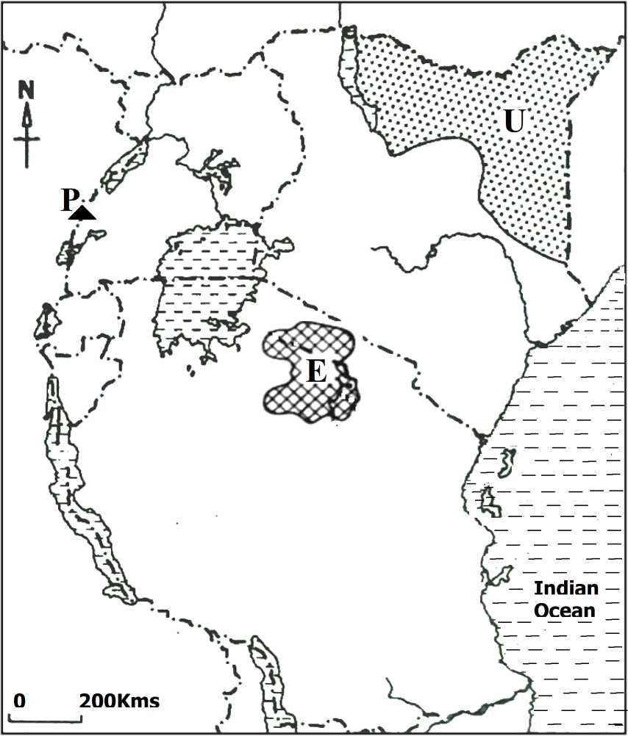

1. State the major economic activity carried out in shaded area U.

………………………………………….…………………………………………………………………………

(b) Which national park is marked E?

………………………………………………………………………………………

(c) Name the main cash crop grown by the people who settled on the slopes of mountain P.

(d) On the map above, use letter **B** to show the river on which

the Seven folks dam project was established.

………………………………………………………………………………………

42. (a) Give any two reasons why some pupils change

schools.

(i)………………………………………………………………………………………

(ii)………………………………………………………………………………………

(b) State any two causes of school dropouts.

(i)………………………………………………………………………………………

(ii)…………………………………………………………………………………….

43. (a) What was the Trans-Atlantic trade?

………………………………………………………………………………………

(b) Mention any two West African tribes which participated in Trans Saharan trade. .

………………………………………………………………………………………

(c) Mention any one role played by the Berbers in the Trans Saharan trade.

………………………………………………………………………………………

44. (a) Why is timber from mangrove forests suitable for ship

building?

………………………………………………………………………………………

(b) Where in East Africa are mangrove forests found?

………………………………………………………………………………………

(c) Give one reason why mangrove forests grow in the area you have mentioned in 44 (b) above.

………………………………………………………………………………………

45. Study the diagram below and answer the questions about it.



(a) Name the social activity that involves the use of the items above.

………………………………………………………………………………………

(b) Give one reason why pupils should be encouraged to participate in the above social activity.

………………………………………………………………………………………

(c) Name the place where the Uganda cranes can host international matches.

………………………………………………………………………………………

(d) Give any one benefit Uganda enjoys when she participates in Olympic Games?

………………………………………………………………………………………

46. (a) What was the Great Trek?

………………………………………………………………………………………

………………………………………………………………………………………

(b) Mention any two places that were occupied by the Dutch after the Great Trek.

…………………………………………………………………………………..

…………………………………………………………………………………

(c) State any one result of the Great Trek.

…………………………………………………………………………………

…………………………………………………………………………………

47. (a) Rwenzori is Uganda’s block mountain. Mention the block mountain that is found in Kenya.

………………………………………………………………………………………

b) Mention the process that led to the formation of block Mountains.

………………………………………………………………………………………

c) In which two ways are landforms like mountains important to people who live around them?

(i)……………………………………………………………………………………

(ii)……………………………………………………………………………………

48. (a) Name any one place at school where waste materials can

be disposed.

…………………………………………………………………………………

1. State any two problems caused by poor waste management

in schools.

………………………………………………………………………………….

(c) Why is recycling important in waste management?

in schools.

………………………………………………………………………………….

49. Match the following correctly.

Turkana River Lake Nilotes

Sabiny Bantu

Akamba Highland Nilotes

Acholi Plain Nilotes

(i) Turkana……………………………………………………………………………

(ii) Sabiny……………………………………………………………………………..

(iii) Akamba …………………………………………………………………………..

(iv) Acholi………………………………………………………………………………

50. (a) State one reason why security is an important service in

an area?

………………………………………………………………………………………

(b) Give any two reasons why most Ugandans have lost trust in security organs.

(i)……………………………………………………………………………………

(ii)……………………………………………………………………………………

1. State any one way security organs can restore the lost trust among Ugandans.

………………………………………………………………………………………

**For numbers 51 - 55 answer either Christianity or Islam but not both alternatives in a number.**

51.Either:

(a) Name any one of the apostles of Jesus Christ who was closest to Him.

………………………………………………………………………………………

1. State any two ways in which a good Christian should behave.

(i)……………………………………………………………………………………

(ii)……………………………………………………………………………………

Or:

1. Name any one companion of Prophet Muhammad (PBUH) who was closest to him

………………………………………………………………………………………

1. Mention any one reason why Prophet Muhammad (PBUH) had companions.

………………………………………………………………………………………

(c) State any two ways in which a good Muslim should behave.

(i)……………………………………………………………………………………

(ii)……………………………………………………………………………………

**52. Either:**

(a) Which day marks the start of fasting period for Christians?

………………………………………………………………………………………

(b) State any **two** reasons why Christians fast.

(i)……………………………………………………………………………………

(ii)……………………………………………………………………………………

(c) Give any **one** way how a Christian observes fasting period.

………………………………………………………………………………………

**Or:**

(a) What marks the start of fasting period in Islam?

………………………………………………………………………………………

(b) State any **two** reasons why Moslems fast.

(i)……………………………………………………………………………………

ii)……………………………………………………………………………………

(c) Give any **one** way in which a Moslem observes the fasting period.

………………………………………………………………………………………

**53. Either:**

1. Name the helper God gave Moses when going to Egypt.

…….…………………………………………………………………………………

1. What role did the helper in (a) above do before the Pharaoh?

………………………………………………………………………………………

1. Give any two evidences to show that God protected the

Israelites in Egypt.

**Or:**

1. Name the helper Allah gave to Prophet Musa when going

to Misiri.

……………………………………………………………………………………….

1. What role did the helper in (a) above do before the Pharaoh?

………………………………………………………………………………………

1. Give any two evidences to show that Allah protected the

Ban- Israel in Misiri.

………………………………………………………………………………………

**54. Either:**

(a) Name the day when Christians celebrate Jesus' triumphant entry in Jerusalem.

………………………………………………………………………………………

(b) Why was Jesus not happy when he entered the temple in Jerusalem?

………………………………………………………………………………………

(c) Give any **two** ways in which Jesus showed unhappiness when He entered the temple in Jerusalem.

(i)………………………………………………………………………………………

(ii)………………………………………………………………………………………

**Or:**

(a) Who was the first woman to convert to Islam?

………………………………………………………………………………………

(b) Why was Prophet Muhammad not happy with the way of worship of the Quraysh?

………………………………………………………………………………………

(c) Give any **two** ways in which the Quraysh showed unhappiness for Prophet Muhammad (PBUH).

(i)……………………………………………………………………………………

(ii)……………………………………………………………………………………

**55. Either:**

(a) When do Christians start fasting?

………………………………………………………………………………………

(b) How do Christians benefit from fasting?

………………………………………………………………………………………

1. Give one practice among Christian during the lent period.

………………………………………………………………………………………

1. How long does the lent period take?

………………………………………………………………………………………

**Or:**

(a) When do Moslems start fasting?

………………………………………………………………………………………

(b) How do Moslems benefit from fasting?

………………………………………………………………………………………

(c) Give one practice among Moslems during Ramadhan.

………………………………………………………………………………………

1. How long does Ramadhan take?

………………………………………………………………………………………

**THE END**